

**SECTION 52 REPORT JUNE 2025**

**PART 1**

## QUARTERLY BUDGET AND PERFORMANCE ASSESSMENT REPORT

# **1.MAYOR’S REPORT (TO BE ATTACHED)**

# **2.COUNCIL RESOLUTION (TO BE ATTACHED**)

### **3.EXECUTIVE SUMMARY**

The 4th quarter report of the Municipality is prepared as per Section 52 of the Municipal Finance Management Act that deals with requirements for quarterly reporting, the section further states that the Mayor of the Municipality must within 30 days of the end of each quarter submit a report to council on implementation of the Budget and the financial state of the Municipality of which it clearly predict the performance of the application of sound financial management principles for the compilation of the approved MTREF to ensure that the Municipality remains financially viable and that municipal services are provided sustainably, economically and equitably to all communities.

## 4. Budget Statements Tables: Quarterly Assessments

#### **Table C1: Quarterly Budget Statement Summary – Quarterly Assessment**

Total Revenue allocated for the current financial year is R631.9 million excluding Capital revenue, revenue to an amount of R17.1 million was received or billed for the 4th quarter ending June 2025 and the year to date revenue amount to R615.2 million, which reflects 11% of the projected quarterly revenue of R157.9 million and 97% performance of the total allocation.

The original budget for operating expenditure was R 722.4 million and it has been adjusted to R754.1 million, expenditure incurred for the 4th quarter ending June 2025 amounts to R127.9 million, and the year-to-date expenditure is R506.2 million. This reflects 68% of the quarterly projections of R188.5 million and of 67% performance of the total budget.

The original capital budget was R243.5 million and it has been adjusted to R273.2 million, the expenditure incurred for 4th quarter ending June 2025 is R 62.6 million and year to date expenditure amounts to R240 million, this indicates 92% of the Quarterly projections of R68.3 million and 88% of budgeted amount.

Taking the above into consideration the net operating surplus/ (deficit) forecast for June 2025 amounts to R290 million while the primary bank balance is R47.3 million.



#### **Table C2: Quarterly Financial Performance by Vote**

Table C2 measures the actual performance against the year-to-date SDBIP which is realized by function for revenue and expenditure. The 30th

of June 2025 forecast figures by function are reflected in the last column, full year forecast. The actual revenue for the Quarter ending June 2025 is R65.7 million, year to date amount to R796.3 million. The actual expenditure incurred is R127.9 million and to date is R506.2 million.

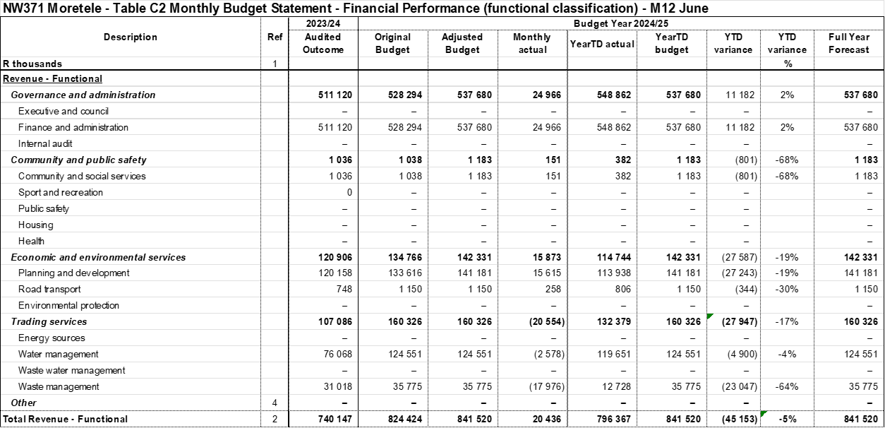



**Table C4: Quarterly Financial Performance by Revenue Source and Expenditure Type**

This table provides the actual performance details for revenue by source and expenditure by type. The revenue budget for 2024/25 amounts to R631.9 million excluding capital budget, the quarterly projections are R157.9 million and actual for the quarter is R17.1 million which reflects unfavorable performance of 11%. The expenditure budget amounts to R754.1 million with a projection of R188.5 million, the actual figure for the quarter is R127.9 million, which reflects 68% of the projected amount.





**Property Rates**

The total budget allocated to Property Rates for the financial year 2024/2025 is R22.1 million. The billed property rates for the 4th quarter ending June 2025 amount to R23.9 million and to date amount to R36.7 million, when compared to the projections of R5.5 million, this results with 435% performance of the projected amount and 166% of the budget amount. The variance is due to some of the properties in the valuation roll that were not updated in the financial system, the journals were proposed to correct the error.

**Interest on Investment**

The total budget for the current financial year is R27.4 million and the interest received for the quarter ending June 2025 June is R7.2 million, year to date amounting to R26.5 million, this indicates 96% of the projected interest of R6.8 million.

**Water service Revenue**

The total budget allocated to water service revenue amount to R38.6 million, the billed water service to date amount to R36 million, this reflects 93% when compared to the budget.

**Waste Management Revenue**

The refuse removal service billed to date amount to R6.4 million, when compared to the total budget of R29.2 million, this results with only 22% performance. There are journals that were proposed to correct the discrepancy.

**EXPENDITURE**

**Contracted services**

The total budget allocation for contracted services was R189.6 million and it has been adjusted to R219.4 million, expenditure incurred for the 4th quarter ending June 2025 is R90.4 million and year to date amount to R209.1 million with the projections of R54.8 million, this indicates 165% performance of the quarterly projections and 95% performance of the budget amount.

**Inventory consumed (Bulk water and Material)**

The total original budget allocated for inventory consumed is R57.7 million, expenditure incurred for the quarter amount to R21.6 million, expenditure incurred to date amount to R51.1 million, when compared to the projected amount of R14.4 million, this indicates 150% performance and 89% of the budget amount. The variance is due to Magalies submitting their invoice late to the municipality.

**Other General Expenditures**

The total general administration expenditure budget amounts to R82.9 million, the expenditure incurred for the quarter is R22.5 million and expenditure incurred to date is R83.8 million, when compared to the quarterly projections of R20.7 million, this reflects 109% of the projected amount.

**Table C5: Monthly Capital Expenditure by Vote**

C5 indicate the actual performance details on Capital Expenditure for all votes.

The original capital budget was R243.5 million and it have been adjusted to R273.2 million, the expenditure incurred for 4th quarter ending June 2025 is R 62.6 million and year to date expenditure amount to R240 million, this indicates 92% of the Quarterly projections of R68.3 million and 88% of budgeted amount.





**Table C6: Quarterly Budget Statement Financial Position**





**Table C7: Quarterly Budget Statement Cash Flow**

Table C7 provide details of the projected cash in- and out flow. A net cash inflow from operating activities of R636.9 million is forecasted, whilst cash used for investing activities amounts to -R233 million is projected. The net increase/decrease amount to R403.8 million, and cash and cash equivalent at month/year amount to R689.7 million.





**PART 2**

## QUARTERLY BUDGET STATEMENT AND PERFORMANCE ASSESSMENT REPORT-SUPPORTING DOCUMENTATIONS

1. **Debtors Analysis**

Supporting table CS3 provides a breakdown of consumer debtors. The outstanding debtors at the end of June amounts to R767.9 million, the major portion of debt is water service with debt of R317.4 million and waste management with R204.7 million. 

1. **Creditors Analysis**

Supporting table SC4 provide details on aged creditors. In terms of the MFMA all creditors should be paid within 30 days of receiving the invoice or the statement. Creditors for an amount of R31.1 million as of 30 June 2025 were not paid.



1. **Investment Portfolio Analysis**

Table SC5 display the council investment portfolio, and it indicates that R205.7 million is invested as at the end of June 2025.



1. **Allocation and grants receipts and expenditure**

**4.1 Municipal Infrastructure Grants (MIG)**

Total Budget allocated for MIG for the current financial year was R133,6 million and it was adjusted to R141 million(the amount include R8.3 million of the approved roll over), an amount received to date is R132.8 million, the expenditure incurred for 4th quarter ending June 2025 is R32.5 million, and year to date actual amount to R141million, which reflects 92% performance of the quarterly projections of R35.2 million and 100% of the allocated amount.

**4.2** **Financial Management Grant (FMG)**

Total allocation for FMG for the current financial year is R2,9 million, the expenditure incurred for the 4th quarter ending June 2025 is R7 hundred and the expenditure to date is R2.9 million which reflects 98% of the quarterly projections of R725 thousand and 100% of the amount received.

**4.3 Water Service Infrastructure grant (WSIG)**

Total allocation for WSIG for the current financial year is R75 million, the amount received to date is R75 million. The expenditure incurred for the 4th quarter ending June 2025 is R18.7 million, and year to date amount to R75 million, this reflects 99% of the quarterly projections of R18.7 million and 100% of the amount received.

**4.4 Expanded Public Works Program Grant (EPWP)**

Total allocation for EPWP is R1,5 million, the amount received to date is R1.3 million and there was no expenditure incurred for the quarter ending June 2025 and the expenditure to date is R1.3 million, this reflects 100% performance of the amount received.

4.5 **Library Grant**

The total Budget allocation is R1 million, amount received to date is R1 million and the expenditure incurred for the 4th quarter ending June 2025 is R6 hundred, and expenditure to date amount to R1 million, which reflects 100% of the amount received.





1. **Councilors allowances and Employee Benefits**

5.1 **Employee related Cost**

The total Budget allocation for Employee related cost for the current final year is R185.1 million, the expenditure incurred for 4th quarter ending June 2025 is R32.2 million, the expenditure incurred to date is R134.2 million, which reflects 70% of the projected amount of R46.2 million and 73% of the budget allocated.

5.2**. Councillors Remuneration**

The total budget allocation for Councillors remuneration is R23.6 million, and expenditure incurred for 4th quarter ending June 2025 is R6.6 million and expenditure incurred to date is R27.9 million, when compared to the quarterly projected amount of R5.9 million, these results with 111% performance and 118% of the budget. The variance is due to system error (salary integration),there are journals that were proposed to correct the error.



1. **Material variances to the delivery service and budget implementation plan**







## Parent municipality financial performance





**8. Municipal entity financial performance**

The municipality does not have an entity

**9. Capital Programme Performance**

The original capital budget was R243.5 million and it have been adjusted to R273.2 million, the expenditure incurred for 4th quarter ending June 2025 is R 62.6 million and year to date expenditure amount to R240 million, this indicates 92% of the Quarterly projections of R68.3 million and 88% of budgeted amount.









## 10. Other Supporting documents





|  |  |  |  |  |
| --- | --- | --- | --- | --- |
|  | | | | |
|  |  |  |  |  | |  |  |

**11. In-year reports of Municipal entities attached to the municipality ‘s in year report.**

The municipality does not have an Entity

**12. Municipal Manager’s quality certification**

(Quality Certificate attached)